**Online Three-Dimensional (3D) Touring for City Museum of Cagayan de Oro and Heritage Studies Center using Roblox Studio**

Brixel C. Tagubar

John Lemar L. Gonzales

Nestor Rj Apal

[MAY 2023]

**TABLE OF CONTENT**

**Chapter 1 -** Background of the Study **PAGE**

Introduction 2 - 5

Statement of the problem 6 - 7 Statement of the Objective 8

Significance of the Study 9 - 11

Scope and limitation 11

Definition and Terms 12

**Chapter 2**

Review of Related Literature 13 - 21

**Chapter 3 -** Material and Methods

Research design 22

Process Flow Diagram 23

Current System Flow 24

Proposed System Flow 25

Minimum Hardware Requirements 26 - 27

Minimum Software Requirements 27

Wireframe 28 - 32

**References** 33 - 36

**Appendix**

Interview Questionnaire 37 - 39

Grammarly Test Result 40

Plagiarism User Result 41

Curriculum vitae 42 - 44

**CHAPTER I**

**THE PROBLEM AND ITS SCOPE**

**Introduction**

According to Boboc R. et al. (2022), 3D technology is a rapidly growing trend across various fields, including education and tourism. This development is due to the emergence of internet platforms and software tools, which have led museums and historical sites worldwide to explore the possibility of providing visitors with an immersive and interactive experience using 3D technology. The ability to virtually explore historical sites, landmarks, and museums has opened up new possibilities for remote learning and virtual tourism, making education and tourism more accessible worldwide. The integration of 3D technology in various fields continues to evolve, promising even more exciting and immersive experiences in the future (Caciora et al., 2021).

3D technology has generated virtual reproductions of cultural heritage sites and museums, enabling remote visitors to explore and engage with these locations (Balletti & Ballarin, 2019). The Smithsonian National Museum of Natural History has developed a 3D virtual tour of its famous dinosaur exhibit, allowing visitors worldwide to experience the exhibit without physically being there. Similarly, the British Museum has employed 3D scanning technology of the Rosetta Stone and replicas of some of its exhibits (British Museum, n.d.). These examples demonstrate the potential of 3D technology to enhance the accessibility and engagement of cultural heritage sites.

There have been efforts in the Philippines to incorporate technology into preserving and promoting cultural heritage. The National Museum of the Philippines has developed a website that provides virtual tours of some of its exhibits (National Museum of the Philippines, n.d.). The Intramuros Administration has also launched a mobile app that provides visitors with an interactive tour of the historic walled city of Intramuros (Intramuros Administration, n.d.).

Numerous studies have demonstrated that 3D virtual environments can positively impact learning outcomes and engagement in educational settings (Xiaoqin et al.., 2022). Meier, C., Saorín, J. L., Bonnet de León, A., & Guerrero Cobos, A. (2020) conducted a study that utilized Roblox Studio to create virtual tours of university campuses, revealing that the immersive and interactive nature of the virtual tours resulted in a more engaging and informative experience for prospective students. Cecile Meier et al. (2020) also developed a virtual museum tour using Roblox Studio, finding that the 3D environment offered a unique and interactive means for visitors to explore museum exhibits.

Several studies have shown that incorporating accessibility features in 3D virtual environments can benefit people with disabilities (Saksono et al., 2020). Adding features such as closed captions, audio descriptions, and alternative text can improve accessibility and enhance learning outcomes for users with visual or hearing impairments. Additionally, assistive technologies, such as screen readers and

joysticks can enable users with physical disabilities to navigate and interact with 3D virtual environments (Kane et al., 2014). By incorporating accessibility features, our 3D Touring System for the City Museum of Cagayan de Oro and Heritage Studies Center using Roblox Studio can provide an inclusive and engaging learning experience for all users, regardless of their abilities.

Built on the conclusions derived from earlier research, the study on "Online 3D Touring for City Museum of Cagayan de Oro and Heritage Studies Center using Roblox Studio" can utilize the immersive and interactive nature of 3D virtual environments created using Roblox Studio to enhance user engagement and promote learning outcomes. The museum's virtual tour can provide a unique and interactive way for visitors to explore the exhibits, similar to the study conducted by Cecile Meier et al. (2020) on virtual museum tours. Additionally, the integration of gamification elements such as achievements, rewards, and leaderboards in the virtual environment can further enhance user motivation and participation, as shown in previous research on gamification in educational settings (Silva et al., 2018; Khattak et al., A. (2019). Thus, leveraging the capabilities of Roblox Studio, this research can create an engaging and interactive 3D virtual tour of the City Museum of Cagayan de Oro and Heritage Studies Center, potentially enhancing user engagement and promoting learning outcomes.

This research aims to develop an online 3D touring platform for the City Museum of Cagayan de Oro and Heritage Studies Center utilizing Roblox Studio. The study seeks to create a platform for enhancing visitor engagement and accessibility to the museum's exhibits. Existing research on the utilization of Roblox Studio for online school tours is limited, and this study aims to bridge this gap by developing and assessing a virtual 3D tour game that incorporates gamification elements to promote engagement and motivation among users. The findings of this research have implications for virtual tours in other educational settings, shedding light on the potential of gamification as a strategy to enhance user engagement and motivation in online educational experiences.

# Statement of the Problem

The City Museum of Cagayan de Oro and Heritage Studies Center aims to promote cultural heritage through online 3D touring using Roblox Studio. Several challenges must be addressed to engage users and ensure the project's sustainability. These challenges include problems identified through interviews with museum staff, potential virtual tour users such as students, persons with disabilities, and other relevant parties.

**Lack of Access to Physical Museum Visits.** Despite the significance of the City Museum of Cagayan de Oro and Heritage Studies Center as cultural heritage sites, accessing them in person may be challenging due to geographical distance, time limitations, or health and safety considerations. This restricts the opportunity for wider audiences to explore and experience these sites.

**Need for Innovative Solutions for Cultural Heritage Preservation:** Preserving and promoting cultural heritage is crucial for safeguarding the identity and history of a place. Traditional preservation methods may only sometimes be sufficient in reaching diverse and global audiences.

**Limited Accessibility:** Physical museums may not be fully accessible to individuals with disabilities, limiting their ability to engage with the exhibits and learn about cultural heritage.

**Lack of Awareness:** Even among city residents, many may need to be made aware of the existence or significance of the City Museum of Cagayan de Oro and Heritage Studies Center. This lack of awareness may prevent potential visitors from seeking out the museum in person or online, leading to low visitation rates and reduced exposure for the museum.

**Inadequate Online Presence:** The current static website for the museum may not effectively showcase the exhibits or provide an engaging user experience. This may deter potential visitors from exploring the museum's offerings and limit its potential to attract new visitors and supporters.

**Statement of Objectives**

**General Objective**

This research aims to develop an online 3D touring experience for the City Museum of Cagayan de Oro and Heritage Studies Center using Roblox Studio. The following specific objectives will be pursued to achieve this goal:

**Aims explicitly to the following:**

* Provide an engaging and educational experience for visitors, supplement classroom learning, and raise cultural heritage awareness.
* Design a user-friendly and engaging interface for the online 3D touring experience, ensuring easy navigation and interaction for visitors.
* Develop a virtual replica of the City Museum of Cagayan de Oro and Heritage Studies Center using Roblox Studio, utilizing 3D modeling, texturing, and scripting to create an immersive and interactive online environment.
* To pilot test the 3D tour and to ensure the effectiveness and usability of the online 3D touring experience developed for the City Museum of Cagayan de Oro and Heritage Studies Center.
* Deploy the virtual tours on the Roblox platform, making them accessible to a broad audience through the internet.

**Significance of the Study**

The significance of this study lies in its potential to revolutionize the online touring experience for the City Museum of Cagayan de Oro and Heritage Studies Center. Developing an immersive and interactive virtual environment through 3D modeling, texturing, and scripting techniques can significantly enhance the preservation and promotion of cultural heritage in the region.

*The outcomes of the study will be tremendously valuable to the following:*

**Visitors.** The online 3D touring experience using Roblox Studio for the City Museum of Cagayan de Oro and Heritage Studies Center has the potential to provide visitors with an engaging and educational platform to explore the history and culture of Cagayan de Oro City. Through immersive virtual environments, multimedia content, and interactive elements, visitors can have an enriching and convenient learning experience that complements traditional classroom learning.

**Students.** Implementing an online 3D touring experience using Roblox Studio for the City Museum of Cagayan de Oro and Heritage Studies Center can benefit students by offering an immersive and interactive platform to explore the history and culture of the region. Through 3D modeling, texturing, and scripting techniques, students can actively learn and develop a deeper understanding of cultural heritage. The virtual tours' multimedia content and interactive elements within the virtual tours can enhance student's learning outcomes, foster critical thinking, and inspire a lifelong interest in cultural heritage preservation.

**Teachers.** The online 3D touring experience using Roblox Studio for the City Museum of Cagayan de Oro and Heritage Studies Center can benefit the faculty and staff by providing an immersive and educational tool to enhance teaching, research, and outreach efforts. The virtual tours offer interactive and multimedia-rich content that can be used to deliver engaging lessons, create interactive learning experiences, and disseminate information about cultural heritage. This can enhance their expertise, attract more visitors, and raise awareness about cultural heritage preservation.

**Future Researchers.** The proposed online 3D touring system for the City Museum of Cagayan de Oro and Heritage Studies Center using Roblox Studio has many significant implications for future researchers in cultural heritage preservation and virtual tourism. The study can serve as a model for developing immersive and interactive virtual tours that promote cultural heritage among users. The methodology and techniques utilized in this study, such as 3D modeling, texturing, and scripting, can provide valuable insights for future researchers seeking to develop similar systems.

Using Roblox Studio, an innovative online 3D touring experience is being developed for the City Museum of Cagayan de Oro and Heritage Studies Center. Visitors, students, and teachers can use this platform, and it has the potential to serve as an immersive way to explore the rich history and culture of Cagayan de Oro City. The virtual tours incorporate 3D modeling, texturing, and scripting techniques, providing an interactive experience that can help promote cultural heritage preservation and awareness. The end goal is to attract more visitors, foster community engagement, and support the museum's mission of cultural heritage preservation and promotion. As a result, this effort could also potentially boost local tourism and economic development.

**Scope and Limitations**

This research aims to develop an online 3D touring experience for the City Museum of Cagayan de Oro and Heritage Studies Center. The 3D models and environment will be created inside Roblox Studio. The programming of interactive elements and user interface will also be done inside Roblox Studio using the programming language called Lua, a built-in and easy-to-learn programming language inside Roblox Studio, to ensure an engaging and user-friendly experience.

The research's limitations will depend on the technical capabilities of Roblox Studio and other software tools used in the development of the online 3D touring experience. Additionally, the availability and access to the museum's artifacts and heritage displays for digitization and integration into the virtual tour may need to be improved. The research will also need to consider the potential privacy, security, and copyright issues that may limit the use of certain materials in the virtual tour.

**Definition of Terms**

**Accessibility Features.** Tools and design elements are implemented within a virtual environment to ensure the experience is inclusive and usable by individuals with various disabilities or limitations.

**Collaborative Exploration.** A feature that enables multiple users to simultaneously explore a virtual environment together, promoting social interaction and shared learning experiences.

**Digital assets.** Digital resources and materials used in developing and creating a project, such as photographs and 3D models.

**Online 3D Touring.** A digital method that enables users to explore and navigate three-dimensional representations of real-world locations, such as museums or heritage centers, through the internet.

**Roblox Studio.** Game development software is used to create interactive and engaging experiences.

**User engagement.** The level of interaction and interest users or audiences show when using a platform or experience.

**Virtual Reality.** (VR) is a computer-generated environment with scenes and objects that appear to be accurate, immersing the user in their surroundings.

**3D representation.** A three-dimensional model or rendering that provides a realistic representation of an object or space.

**CHAPTER II**

**REVIEW OF RELATED LITERATURE AND STUDIES**

This chapter discusses concepts, principles, and research relevant to developing an online 3D tour for the City Museum of Cagayan de Oro and the Heritage Studies Center using Roblox Studio. The researchers drew upon various scholarly articles during the conceptualization phase.

Numerous studies have highlighted the efficacy of virtual reality and 3D technology in enriching museum experiences. In a review of empirical research, Kenderdine and Diefenbach (2019) revealed that virtual reality can enhance visitors' engagement and understanding of exhibits. Likewise, Doulamis et al. (2018) conducted a comprehensive review of virtual reality for cultural heritage education and concluded that it improves learning outcomes and delivers immersive experiences. Previous research findings can be applied to developing and creating a platform for the City Museum of Cagayan de Oro and Heritage Studies Center, utilizing Roblox Studio. By incorporating virtual reality and 3D technology, Based on the findings of Kenderdine and Diefenbach, the museum experience for visitors can be enhanced. Additionally, features can be designed to promote learning outcomes and immersive experiences, aligning with the conclusions of Doulamis et al. on cultural heritage education. By leveraging these insights, an innovative online platform can be created to enhance visitor engagement and accessibility to the museum exhibits.

Several museums and cultural heritage sites have utilized Roblox Studio to create virtual experiences for visitors. Uliano et al. (2018) presented a case study that demonstrated the potential of Roblox Studio in creating interactive exhibits and engaging visitors at the Museo Archeologico Nazionale di Napoli. Similarly, Al-Rawi and Almuftah (2019) presented a case study on designing and developing a virtual museum using Roblox Studio, highlighting its user-friendly interface and powerful tools. The case study by Al-Rawi and Almuftah (2019) can serve as a source of inspiration for the design and development of a visually appealing and interactive online 3D touring platform for the City Museum of Cagayan de Oro and Heritage Studies Center, leveraging the user-friendly interface and powerful tools of Roblox Studio. By applying the insights from this case study, an innovative and engaging platform can be developed to enhance the museum experience for visitors and promote accessibility to the exhibits in a virtual environment.

In terms of designing effective virtual experiences, prior research has highlighted the significance of incorporating interactivity and user engagement. Shin and Kang (2019) analyzed interactive exhibitions created with Roblox Studio at the Korean National Museum of Modern and Contemporary Art. They found that these exhibits increased visitors' engagement and provided a unique experience.

Similarly, Besoain, F., Jego, L., & Gallardo, I. (2021) emphasized the importance of interactivity in designing and developing a 3D virtual museum using Roblox Studio. The findings from Shin and Kang (2019) and Besoain, F., Jego, L., & Gallardo, I. (2021) can be utilized to guide the approach to designing an effective online 3D touring platform for the City Museum of Cagayan de Oro and Heritage Studies Center using Roblox Studio. By incorporating interactive elements and promoting user engagement, a unique and immersive virtual experience can be created for visitors. This can include interactive exhibits, virtual tours, and engaging activities encouraging visitors to explore and interact with the museum's collections. By leveraging the insights from these studies, the overall visitor experience can be enhanced, and greater accessibility and engagement with the museum exhibits can be promoted through the online 3D touring platform.

In addition, previous research has explored the potential of Roblox Studio for creating inclusive and accessible virtual experiences. Besoain, F., Jego, L., & Gallardo, I. (2021) underscored the significance of designing virtual experiences that are accessible to all, including individuals with disabilities, and demonstrated how Roblox Studio could be utilized for this purpose. The findings from Besoain, F., Jego, L., & Gallardo, I. (2021) can be used to guide our approach to designing an inclusive and accessible online 3D touring platform for the City Museum of Cagayan de Oro and Heritage Studies Center using Roblox Studio.

By considering accessibility features such as accommodating different abilities, providing alternative ways to interact with exhibits, and ensuring that the platform is usable and navigable for all visitors, a virtual experience that is inclusive and accessible to a wide range of users can be created. This can involve implementing features such as closed captioning, audio descriptions, and alternative input methods to ensure that visitors with disabilities can fully engage with the museum exhibits through our online platform. By leveraging the insights from this research, inclusivity and accessibility can be promoted in the online 3D touring platform, ensuring a meaningful and enjoyable experience for all visitors, regardless of their abilities.

Kim, D., Lee, Y., & Koo, C. (2018) studied factors affecting users' continuance intention in mobile question-and-answer (Q&A) communities, specifically focusing on the perspective of information quality. The findings from this study can be used to inform the design of an online community or forum within the 3D touring platform for the City Museum of Cagayan de Oro and Heritage Studies Center by incorporating measures to ensure information quality based on the conclusions of Kim, Lee, and Koo on factors affecting users' continuance intention in mobile Q&A communities.

In the literature review conducted by Khattak, J.Z., Pandit, R., & Tambe, A. (2019), the relationship between gamification and motivation was the specific focus of the investigation. The review provides insights into how gamification techniques can impact user motivation in the context of online platforms, including the potential benefits and challenges associated with incorporating gamification elements in the design. The review delves into how gamification techniques, such as leaderboards, badges, and rewards, can enhance user motivation by leveraging intrinsic motivators, such as achievement, competition, and social recognition. The review also explores the role of extrinsic motivators, such as points, levels, and virtual goods, in driving user engagement and participation in gamified systems. Furthermore, the review highlights gamification's potential challenges or limitations of gamification, such as the risk of users becoming overly reliant on external rewards instead of developing motivation, or the possibility of gamification elements becoming repetitive and losing effectiveness over time.

The insights gained from this literature review on gamification and motivation can provide valuable guidance for informing the design of the online 3D touring platform for the City Museum of Cagayan de Oro and Heritage Studies Center using Roblox Studio. By considering how gamification elements can be strategically employed to enhance user motivation, engagement, and overall user experience within the platform, the design can be optimized to implement gamification techniques effectively.

The local study by Paderon, E. V., & Chua, R. M. (2018) explores virtual museums as an alternative approach to promoting cultural heritage. The authors discuss how virtual museums can provide accessibility and preserve cultural heritage artifacts. Findings from this study can be applied to the development of the online 3D touring platform for the City Museum of Cagayan de Oro and Heritage Studies Center utilizing Roblox Studio by incorporating features that promote accessibility and preservation of cultural heritage artifacts.

In the study of Reyes, J. R. (2018); and Dela Cruz, M. S., & Reyes, C. D. (2020), they explored the challenges and strategies associated with intellectual property rights in museum collections. The author discusses the importance of understanding and managing intellectual property rights, including copyright, in the context of museum collections. The findings from this study can be applied to the development of the online 3D touring platform for the City Museum of Cagayan de Oro and Heritage Studies Center using Roblox Studio, by implementing strategies to ensure compliance with intellectual property rights and copyright laws in the virtual tour.

Delos Santos and Aquino (2020) conducted a study on the utilization of Roblox Studio as a virtual museum for teaching Philippine history. The authors adopted an interactive approach that leveraged the features of Roblox Studio to create a virtual museum that offered an immersive learning experience for learners. The study found that the use of Roblox Studio as a teaching platform enhanced learners' engagement and understanding of Philippine history.

The interactive nature of the virtual museum created using Roblox Studio provided opportunities for learners to explore exhibits, interact with artifacts, and participate in educational activities. The findings of this study can be applied to developing an online 3D touring platform for the City Museum of Cagayan de Oro and Heritage Studies Center using Roblox Studio. By incorporating interactive elements and immersive experiences, similar to the approach used by Delos Santos and Aquino, the online platform can enhance visitor engagement and facilitate meaningful learning experiences.

Tan and Lim (2019) conducted a study on virtualizing museums using Roblox Studio, with a focus on the Filipino museum experience. The authors explored how Roblox Studio can be used as a platform to create virtual museums that provide an immersive and interactive learning environment for visitors developing that virtualizing museums using Roblox Studio can enhance visitor engagement and accessibility to museum exhibits, allowing learners to explore virtual exhibits, interact with artifacts, and participate in educational activities. The findings of this study can be applied to the development of an online 3D touring platform for the City Museum of Cagayan de Oro and Heritage Studies Center using Roblox Studio. By leveraging the immersive and interactive nature of virtual museums created using Roblox Studio, the online platform can provide a similar engaging and accessible experience for visitors, enabling them to explore the museum exhibits in a virtual environment.

Alip, Regalario, and Magadia (2018) conducted a study on using Roblox as a virtual museum learning platform, focusing on the case of the Philippine National Museum. The authors explored how Roblox can be used to create a virtual museum learning environment that promotes engagement and active learning among learners. The study found that Roblox can provide a platform for virtual museum learning that facilitates learner interaction with exhibits, promotes inquiry-based learning, and fosters critical thinking skills. The findings of this study can be applied to developing an online 3D touring platform for the City Museum of Cagayan de Oro and Heritage Studies Center using Roblox Studio. By incorporating similar features and strategies used in the case of the Philippine National Museum, the online platform can promote active learning, critical thinking, and engagement among visitors as they explore the museum exhibits virtually.

Torres, Rodriguez, and Bautista (2018) studied indigenous data collection approaches and ethical considerations in the Philippines. The authors focused on the unique challenges and considerations when collecting data from indigenous communities in the country, including issues related to cultural sensitivity, community engagement, and ethical considerations. The study discussed various approaches, such as participatory research and community-based methods, that can be used for data collection in indigenous communities in the Philippines.

The authors also highlighted the importance of respecting indigenous knowledge and traditional practices, and ensuring the informed consent of participants. The findings of this study can be used to inform the data collection process for the research on online 3D touring for City Museum of Cagayan de Oro and Heritage Studies Center, particularly in terms of incorporating indigenous perspectives and ensuring cultural sensitivity in data collection practices within the local context of the Philippines.

Overall, the use of Roblox Studio for creating online 3D touring experiences for cultural heritage sites and museums has demonstrated its potential for creating immersive and interactive experiences for visitors. However, designing effective virtual experiences requires careful consideration of interactivity, engagement, accessibility, and user experience. Future research could explore the impact of virtual experiences created using Roblox Studio on visitors' engagement, learning outcomes, and satisfaction.

**CHAPTER III**

**METHODOLOGY**

This chapter presents the strategies and approaches for designing the overall system of the study. It covers various topics, such as research design, process flow, hardware and software requirements, and wireframes, to ensure the successful development of the online 3D touring system for the City Museum of Cagayan de Oro and Heritage Studies Center using Roblox Studio.

**Research Design/Methods**

**Developmental Study**

This study aims to explore the feasibility and effectiveness of using Roblox Studio to create an online 3D touring platform for the City Museum of Cagayan de Oro and Heritage Studies Center. The study will involve designing and developing a virtual museum environment, and evaluating user engagement and learning outcomes. The results of the study will inform the future development and implementation of the online 3D touring platform to promote cultural heritage and increase accessibility for diverse audiences, including persons with disability.

**Process Flow**

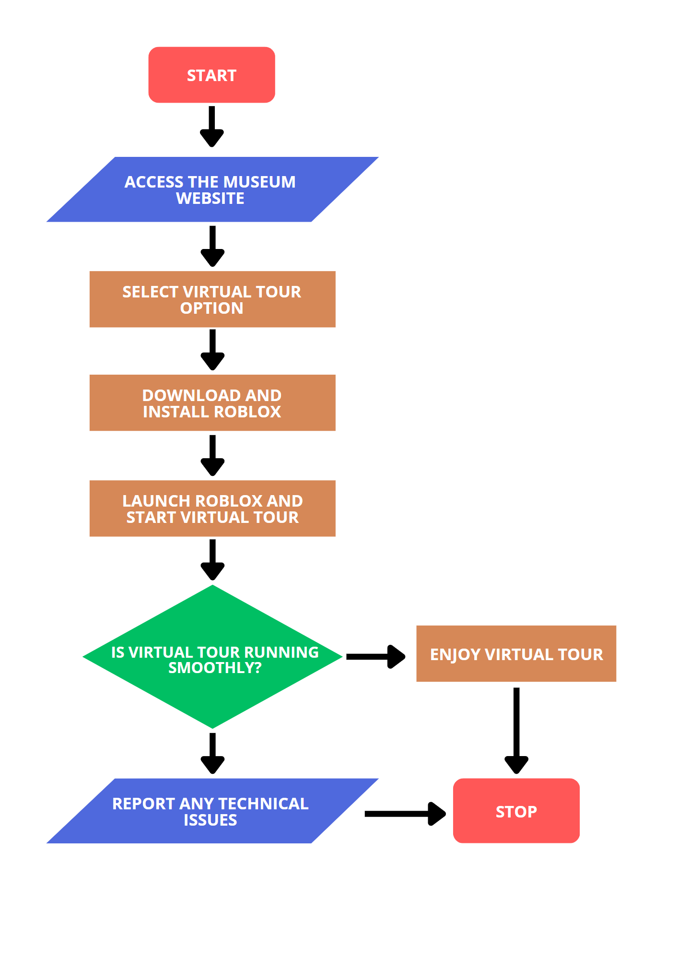

**Current System**

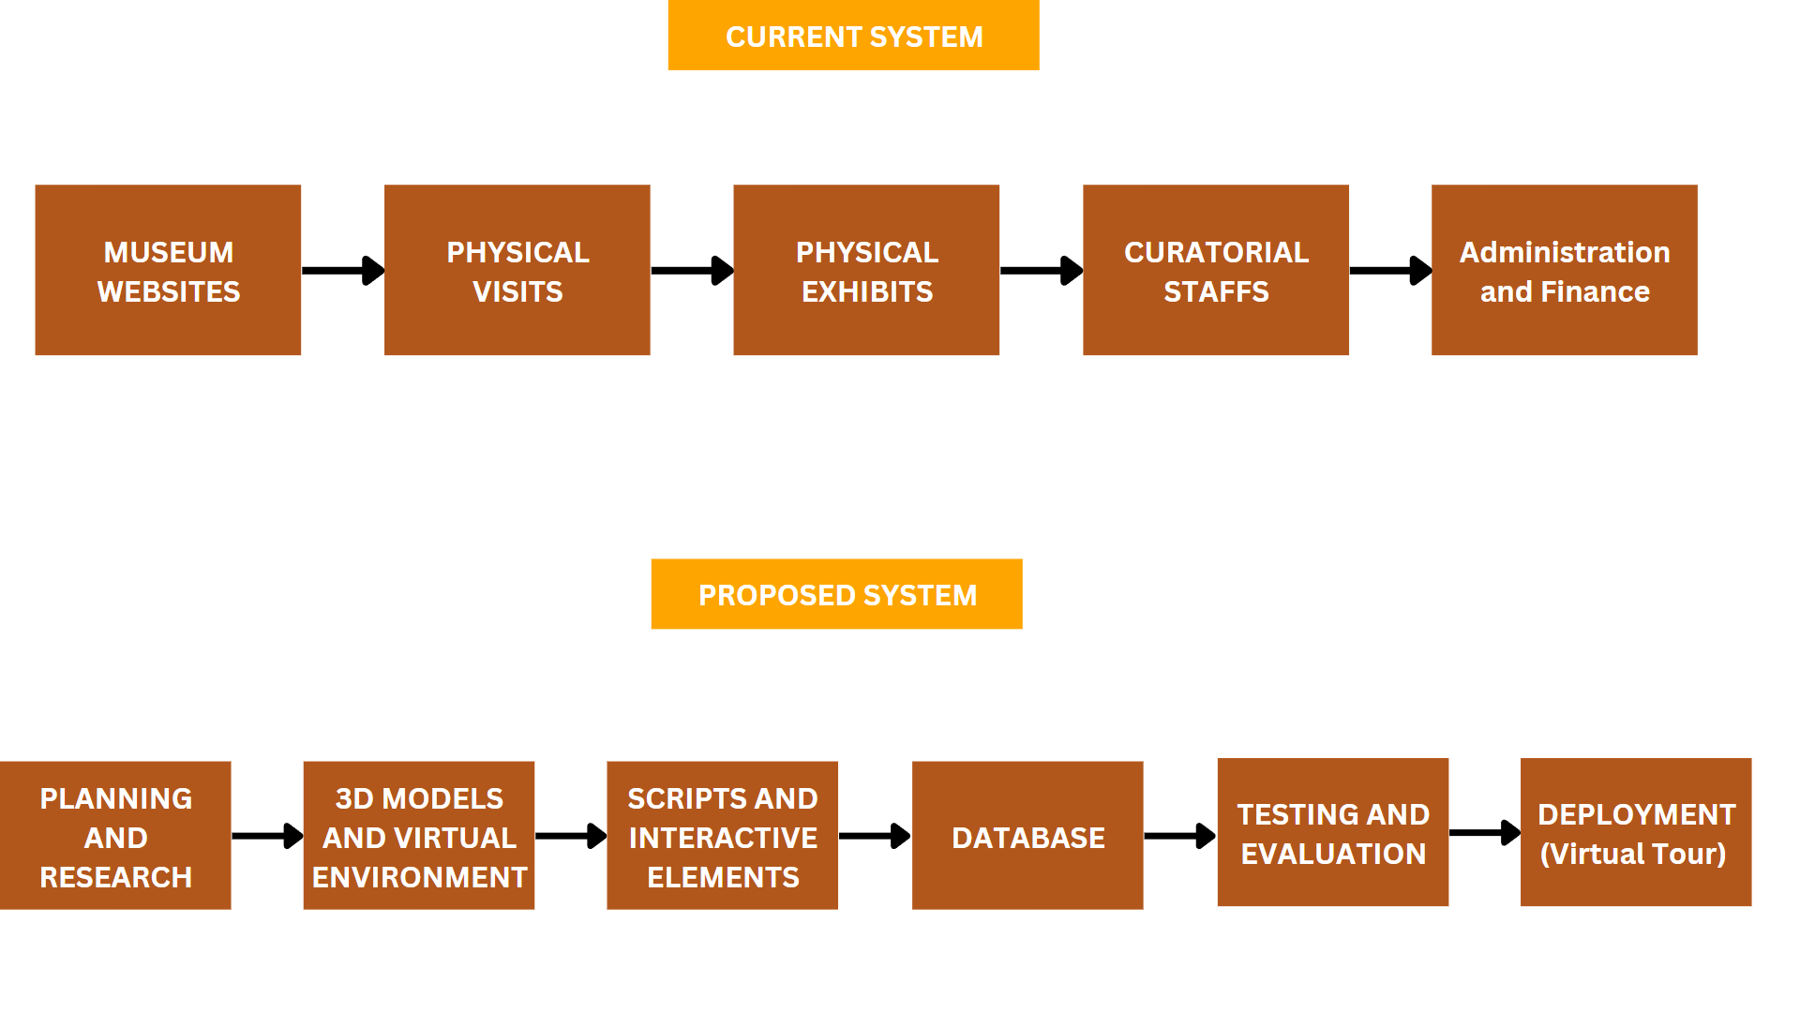

***Figure 1.0 Current System Flow***

Currently, there is no dedicated online 3D touring system for the City Museum of Cagayan de Oro and Heritage Studies Center. Visitors can only access limited information and static images of the museum exhibits through the museum's website or other online platforms. There need to be more interactive and immersive virtual tours that provide an engaging experience for users to explore the museum's artifacts and learn about its rich cultural heritage.

**Proposed System**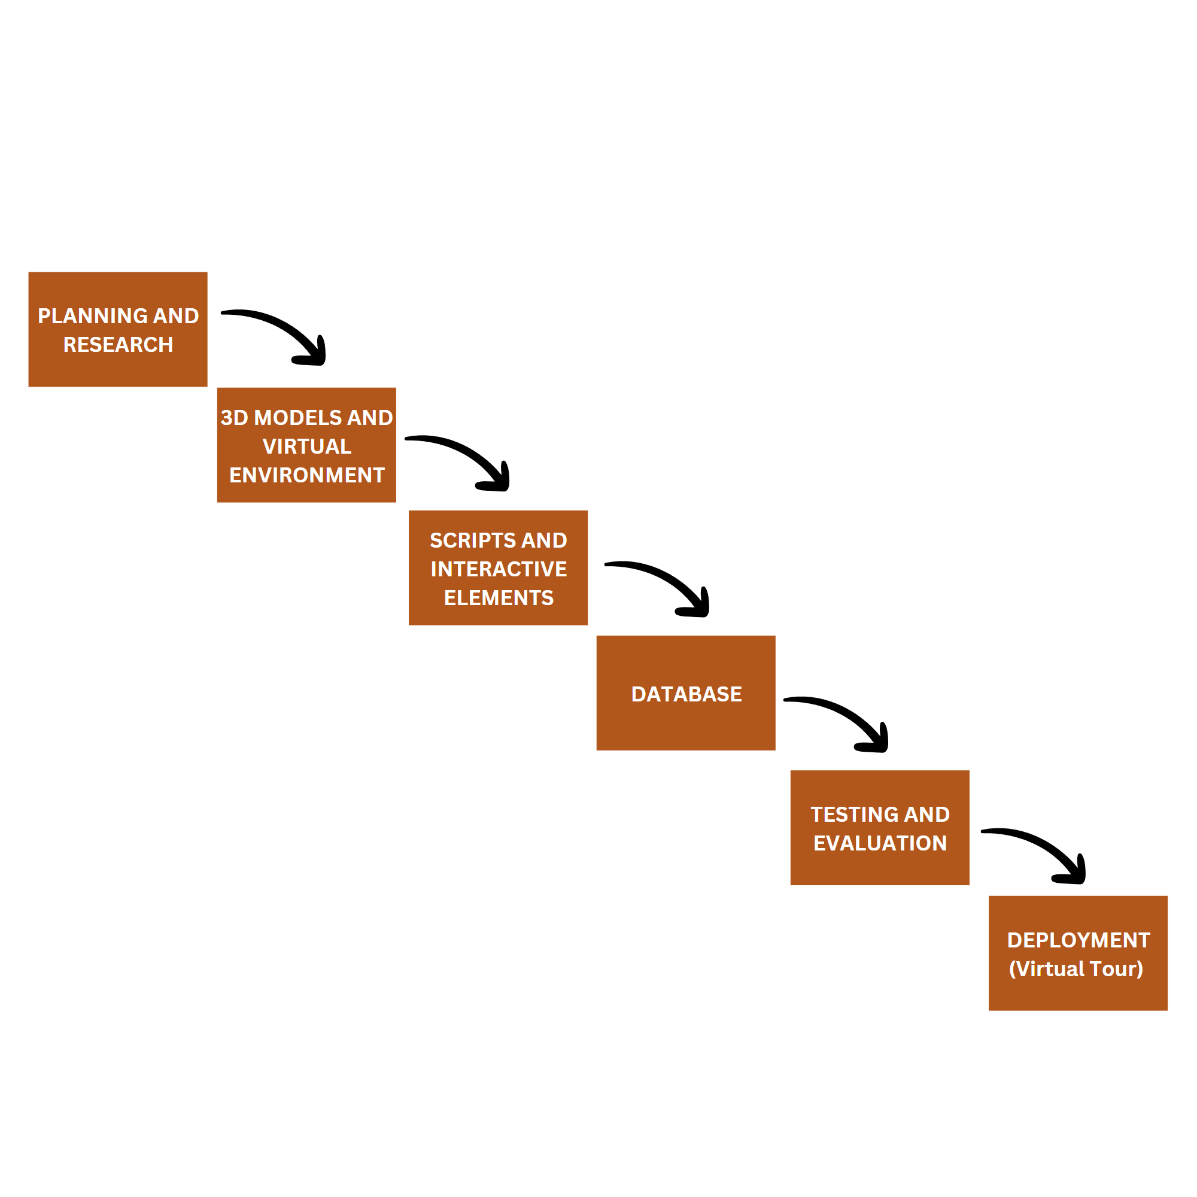

**Figure 2.0 Proposed System Flow**

***Figure 1.1 Current System Flow***

This flowchart illustrates the proposed system for the City Museum of Cagayan de Oro and Heritage Studies Center, which involves leveraging Roblox Studio to create a virtual museum with an immersive experience. The proposed system for the City Museum of Cagayan de Oro and Heritage Studies Center involves using Roblox Studio to create an immersive virtual museum experience for visitors. This includes 3D modeling, texturing, and scripting to develop interactive elements and multimedia content.

**Minimum Hardware Requirements for Personal Computers**

These are the following basic hardware requirements to run this project.

| **HARDWARE COMPONENTS** | **SPECS** |
| --- | --- |
| Operating System | Windows 7 or later, or macOS 10.9 or later |
| Processor | Intel Core i3 or equivalent processor or higher |
| RAM | 4 GB or more |
| Storage | 10 GB or more available storage space |
| Display | Minimum screen resolution of 720p or higher |
| Graphics | Integrated or dedicated GPU with support for OpenGL ES 3.0 or higher |

**Minimum Hardware Requirements for Smartphones**

These are the following basic hardware requirements in order to run this project.

| **HARDWARE COMPONENTS** | **SPECS** |
| --- | --- |
| **Operating System** | iOS 11 or later, or Android 5.0 (Lollipop) or later |
| **Processor** | Quad-core processor or higher |
| **RAM** | 2 GB or more |
| **Storage** | 4 GB or more available storage space |
| **Display** | Minimum screen resolution of 720p or higher |
| **Graphics** | Integrated or dedicated GPU with support for OpenGL ES 3.0 or higher |

**Minimum Software Requirements**

These are the necessary software to run the project entirely.

| **PLATFORM** | **SOFTWARE COMPONENT** | **SPECS** |
| --- | --- | --- |
| Mobile | Roblox **Studio** App | Latest version of the Roblox Studio app for iOS or Android |
| Mobile | Roblox **Player** App | Latest version of the Roblox Player app for iOS or Android |
| PC | Roblox Studio Software | Latest version of Roblox Studio software for Windows or macOS |
| PC | Roblox Player Software | Latest version of Roblox Player software for Windows or macOS |

**Wireframe**

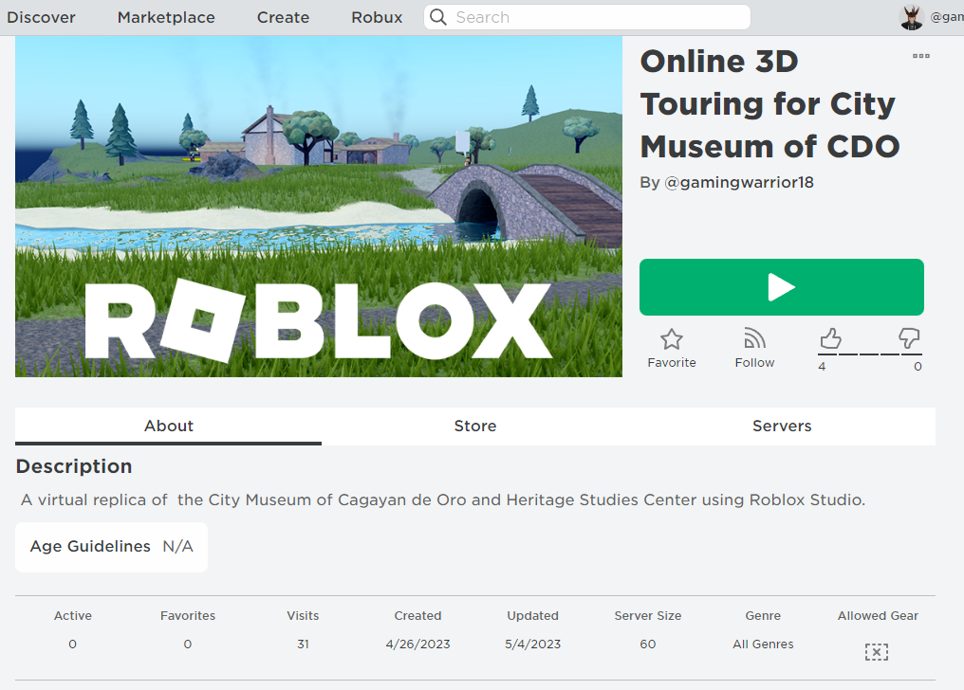

***Figure 2.0 Homepage***

When accessing the Roblox website for the online 3D touring of the City Museum of Cagayan de Oro and Heritage Studies Center, users will first encounter the Homepage image of the game.

**Wireframe**

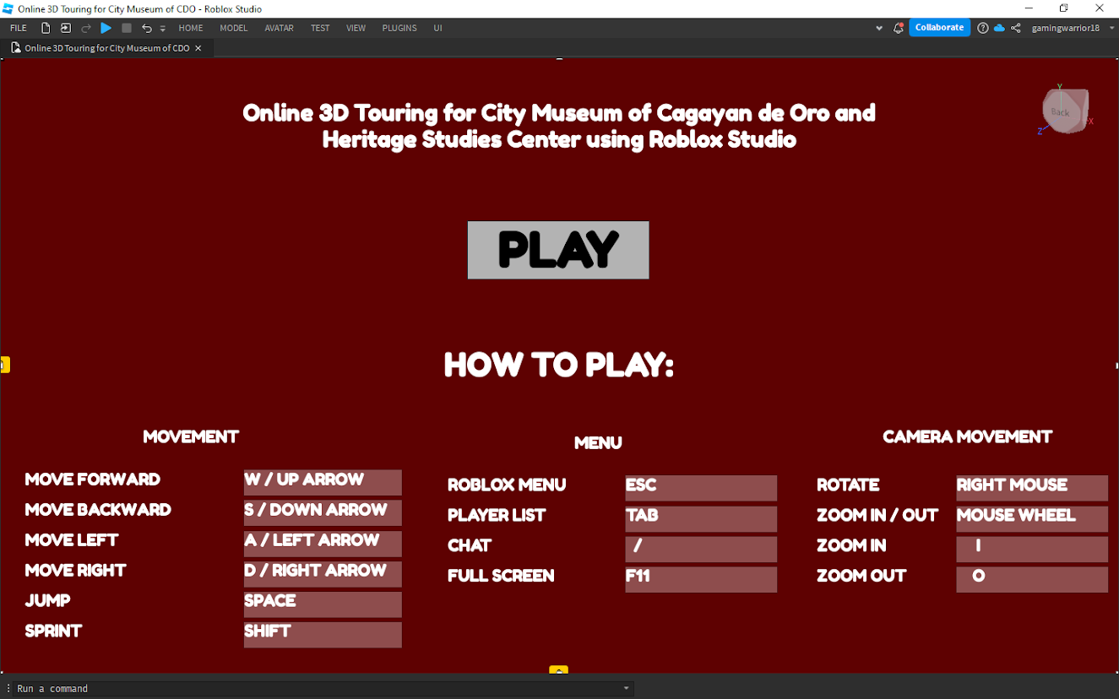

***Figure 2.1 Get Started***

After clicking on the play button, the game will launch and display the Homepage main menu, providing users with options for navigating through the game.

**Wireframe**

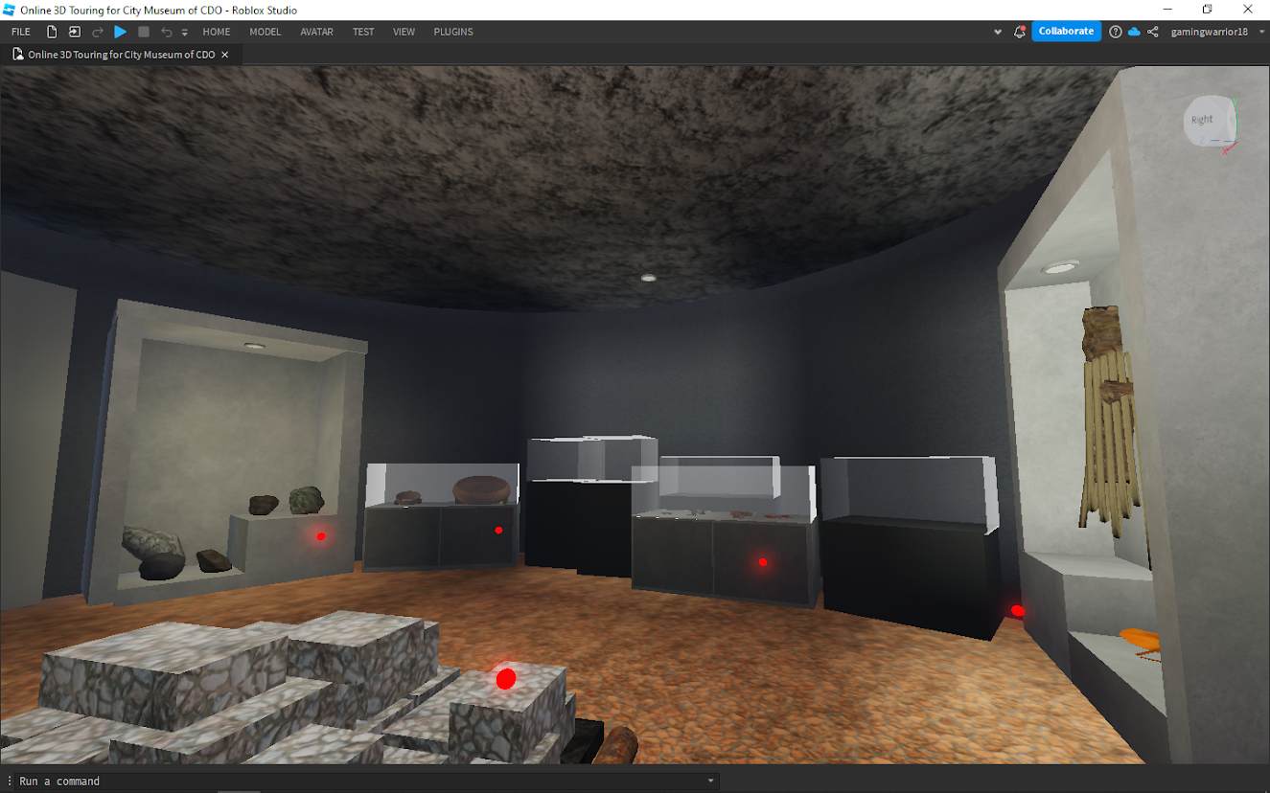

***Figure 2.2 Game Interface***

The game will focus on providing a lifelike, 1:1 replica of the City Museum of Cagayan de Oro and Heritage Studies Center.

**Wireframe**

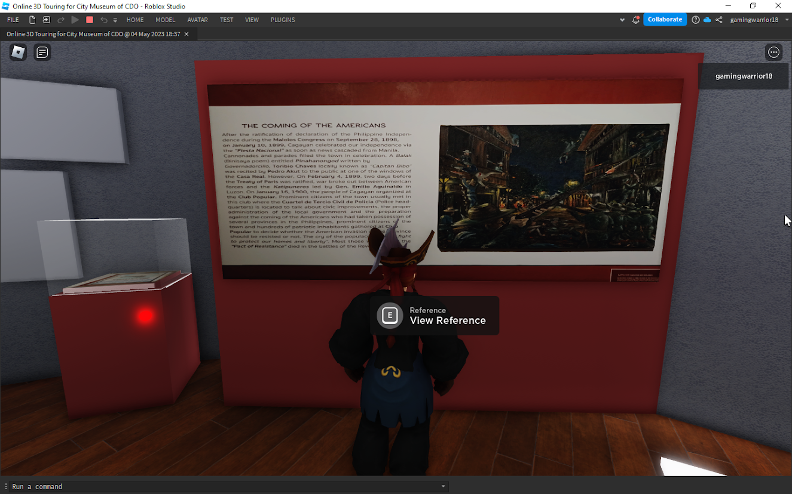

***Figure 2.3 View Reference***

Users will be able to navigate through the game and receive detailed information about the lifelike tour of the City Museum of Cagayan de Oro and Heritage Studies Center.

**Wireframe**

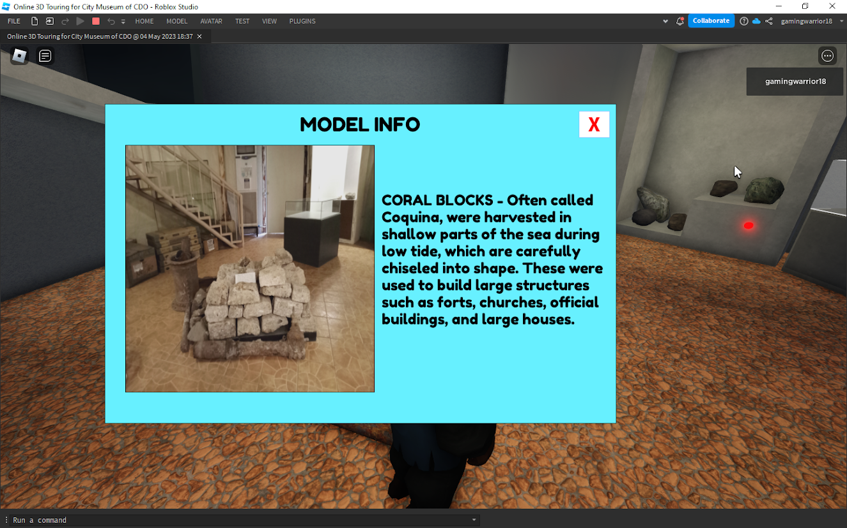

***Figure 2.4 Model Information***

When a user interacts with the artifacts in the game, an image of the particular object and relevant information will pop up, providing users with detailed information about that specific artifact

Alip, R., Regalario, J., & Magadia, J. (2018). Roblox as a Platform for Virtual Museum Learning: The Case of the Philippine National Museum. In Proceedings of the 6th International Conference on Educational and Information Technology (ICEIT 2018) (pp. 87-91). doi:10.1145/3230783.3230803

Brown, D. R. (2019). The use of virtual reality in higher education: Emerging findings and directions for future research. International Journal of Information and Learning Technology, 36(1), 18-29. https://doi.org/10.1108/IJILT-08-2018-0102

Caciora, T., Herman, G. V., Ilieș, A., Baias, Ș., Ilieș, D. C., Josan, I., & Hodor, N. (2021). The use of virtual reality to promote sustainable tourism: A case study of wooden churches and historical monuments from Romania. Remote Sensing, 13(9), 1758. https://doi.org/10.3390/rs13091758

Delos Santos, P. & Aquino, R. (2020). Utilizing Roblox Studio as a Virtual Museum: An Interactive Approach to Teaching Philippine History. International Journal of Virtual and Personal Learning Environments, 11(1), 1-18. https://doi.org/10.4018/ijvple.2020010101

Dela Cruz, M. S., & Reyes, C. D. (2020). Digital Heritage and Copyright: Perspectives from Philippine Museums. Philippine Journal of Cultural Heritage, 3(2), 73-86.

Dicheva, D., Dichev, C., Agre, G., & Angelova, G. (2015). Gamification in education: A systematic mapping study. Educational Technology & Society, 18(3), 75-88. https://www.jstor.org/stable/23723643

Doulamis, A., Karamanis, K., & Nikolopoulos, S. (2018). The use of virtual reality for cultural heritage education: A review. Journal of Cultural Heritage, 31, 101-110. https://doi.org/10.1016/j.culher.2018.01.009

Garcia, R. & Santos, J. (2019). Data Collection in the Philippines: Best Practices and Challenges. Philippine Journal of Social Sciences, 42(2), 123-145.

Kenderdine, S., & Diefenbach, E. (2019). Virtual reality for museums: A review of empirical research. International Journal of Heritage Studies, 25(3), 246-261. https://doi.org/10.1080/13527258.2018.1462794

Kim, D., Lee, Y., & Koo, C. (2018). Factors affecting users' continuance intention in mobile Q&A communities: A information quality perspective. Computers in Human Behavior, 88, 210-220. doi:10.1016/j.chb.2018.06.032

Liu, X., Jiang, M., & Wu, C. (2020). A 3D virtual reality approach to enhancing museum experiences. Journal of Cultural Heritage Management and Sustainable Development, 10(1), 93-110. https://doi.org/10.1108/JCHMSD-01-2020-0003

Liew, T. M. (2018). Digitizing museums and heritage sites: Challenges and opportunities. In Handbook of Research on Cross-Cultural Business Education (pp. 245-267). IGI Global. https://doi.org/10.4018/978-1-5225-3485-3.ch013

Paderon, E. V., & Chua, R. M. (2018). Virtual Museum: An Alternative Approach in Promoting Cultural Heritage. International Journal of Applied Science and Technology, 8(5), 71-79.

Poyiadji, E., & Poyiadji, V. (2019). Utilizing game development platforms for the creation of cultural heritage virtual tours. International Journal of Game-Based Learning, 9(1), 17-32. https://doi.org/10.4018/IJGBL.2019010102

Roblox Corporation. (2020). Roblox Studio. Retrieved from https://devforum.roblox.com/t/introducing-roblox-studio-features/753531

Shin, S. J., & Kang, S. J. (2019). Creating interactive exhibitions with Roblox Studio: An analysis of the Korean National Museum of Modern and Contemporary Art. Journal of Digital Convergence, 17(9), 181-192. https://doi.org/10.14400/JDC.2019.17.9.181

Shehade, M., & Stylianou-Lambert, T. (2020). Virtual reality in museums: Exploring the experiences of museum professionals. Applied Sciences, 10(11), 4031. https://doi.org/10.3390/app10114031

Seo, S., Kim, J., & Bae, J. (2020). Virtual university campus tours: A comparative study of effectiveness between the 3D virtual environment and video tours. British Journal of Educational Technology, 51(4), 1324-1344. https://doi.org/10.1111/bjet.12887

Silva, A., Torres, R., & Vilhena, N. (2018). Game-based learning with Roblox: The case of computer programming. Journal of Information Technology Education: Research, 17, 225-247. https://doi.org/10.28945/4023

Santos, A. L. (2017). Copyright Issues in the Digital Age: Implications for Online Museum Exhibitions. Journal of Museum Studies, 5(2), 112-130.

Tan, J. & Lim, R. (2019). Virtualizing Museums Using Roblox Studio: The Filipino Museum Experience. Asia-Pacific Collaborative Education Journal, 15(2), 187-197.

Torres, M., Rodriguez, L., & Bautista, K. (2018). Indigenous Data Collection in the Philippines: Approaches and Ethical Considerations. Philippine Indigenous Peoples' Journal, 15(1), 87-102.

**Appendices**

**Interview Questionnaire**

**For Museum Staff and Museum Director**

1. What challenges does the museum face in showcasing its collections to a broader audience?
2. How familiar are you with the concept of an online 3D tour? Have you had any prior experience working on similar projects?
3. What are your initial thoughts on implementing an online 3D tour for the museum? Do you see any potential benefits or concerns?
4. Are there any concerns or potential challenges that you foresee in implementing an online 3D tour of the museum?
5. How do you anticipate the online 3D tour would impact the accessibility of the museum for remote visitors and individuals with physical limitations?
6. Are there any specific challenges or considerations in terms of intellectual property rights or copyright issues that you need to ad when digitizing and showcasing the museum's collections online?
7. How do you see the online 3D tour impacting the museum's relationship with its local and international visitors?

**Questionnaire for the Potential Users and Pilot Testers**

1. Have you ever visited a museum or cultural institution before? If so, what aspects of the museum experience did you find most engaging or memorable?
2. How comfortable are you with using technology for virtual tours or online experiences?
3. What types of additional content or interactive elements would enhance your engagement and enjoyment during the online 3D tour?
4. How important is the ability to access the online 3D tour on various devices
5. What device or platform would you prefer to use for the tour?
6. How likely are you to recommend the online 3D tour to others?
7. Are there any specific accessibility considerations or features that you would like to see incorporated into the online 3D tour to accommodate users with disabilities or special needs?
8. How do you think the online 3D tour could complement or enhance the physical museum visit experience?

**Questionnaire for the Pilot Testers**

1. As a pilot tester, what specific aspects or features of the online 3D tour would you like us to focus on during the testing phase?
2. How user-friendly do you find the navigation and controls of the 3D tour? Are there any suggestions or improvements you would recommend in this area?
3. What are your initial impressions of the visual quality and aesthetics of the online 3D tour?
4. How well do you think the online 3D tour conveys the historical and cultural significance of the museum's collections?
5. Have you encountered any technical issues or challenges while using the 3D tour? If so, please describe them and provwill youtions for resolving them.
6. How well does the online 3D tour capture the essence and atmosphere of the physical museum? Do you feel immersed in the 3D environment?
7. What additional features or interactive elements would you like to see incorporated into the online 3D tour to enhance your overall experience?
8. Are there any specific accessibility considerations or features that you would like to see implemented or improved in the online 3D tour to accommodate users with disabilities or special needs?
9. How likely are you to recommend the online 3D tour to others based on your pilot testing experience? What factors would influence your decision to recommend or not recommend it?

**Grammarly Test Result**

**Plagiarism Test Result**

**CURRICULUM VITAE**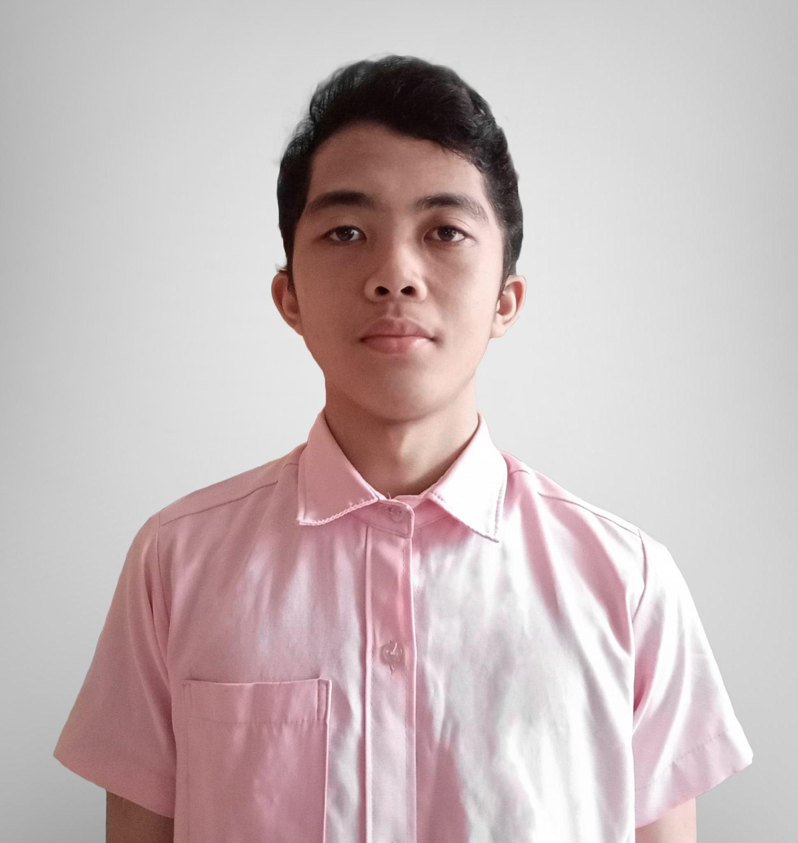

**JOHN LEMAR L. GONZALES**

Tibasak, Macasandig, Cagayan de Oro City

09974161503

jlgonzales13432@liceo.edu.ph

**PERSONAL INFORMATION**

Age: 19 years old

Birthday: April 29, 2004

Place of Birth: Bethel Baptist Hospital Malaybalay City

Citizenship: Filipino

Civil Status: Single

Religion: Roman Catholic

Father’s name: Ramel G. Gonzales

Mother’s name: Jonaline L. Gonzales

**EDUCATIONAL BACKGROUND**

● Elementary Education: Malaybalay Central School and Central School CDO

● Secondary Education: Macasandig National High School

● Senior High School: Liceo de Cagayan University

Strand: Information and Communications Technology

**CURRICULUM VITAE**

**Rj Nestor Apal**

Zone 2 Kauswagan, Cagayan de Oro City

09672185468

nrapal22155@liceo.edu.ph

**PERSONAL INFORMATION**

Age: 18 years old

Birthday: December 6, 2004

Place of Birth: Carmen, Cagayan de Oro City

Citizenship: Filipino

Civil Status: Single

Religion: INC

Father’s name: Nestor B. Apal

Mother’s name: Virginia P. Apal

**EDUCATIONAL BACKGROUND**

● Elementary Education: West City Central School

● Secondary Education: Misamis Oriental General Comprehensive High School

● Senior High School: Liceo de Cagayan University

Strand: Information and Communications Technology

**CURRICULUM VITAE**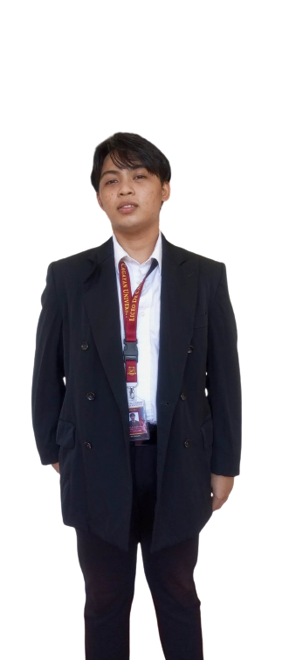

**Brixel Tagubar**

Zone 2A carmen vamenta blvd, Cagayan de Oro City

09666207283

btagubar48286@liceo.edu.ph

**PERSONAL INFORMATION**

Age: 21 years old

Birthday: February 12, 2002

Place of Birth: Cagayan de Oro city Misamis Oriental

Citizenship: Filipino

Civil Status: Single

Religion: Roman Catholic

Father’s name: Roldan S. Tagubar

Mother’s name: Antoñia S. Callao

**EDUCATIONAL BACKGROUND**

● Elementary Education: West City Central School

● Secondary Education: Misamis Oriental General Comprehensive High School

● Senior High School: Liceo de Cagayan University

Strand: Information and Communications Technology